Single Cell Protein
Single cell protein refers to edible protein extracted from pure microbial cultures or dried cell biomass. Microbeslike algae, fungi, yeast, and bacteria have very high protein content in their biomass (Table 1). These microorganisms can be grown using inexpensive substrates like agricultural waste viz. wood shavings, sawdust, corn cobs etc. and even human and animal waste. The microorganisms utilize the carbon and nitrogen present in these materials and convert them into high-quality protein which can be used as a supplement in both human and animal feed. The single cell proteins can be readily used as fodder for achieving fattening of calves, pigs, and poultry and even in fish breeding.
Single Cell Protein (SCP) offers an unconventional but plausible solution to this problem of protein deficiency being faced by the entire humanity.
Table 1: Average different compositions of the main groups of microorganisms (% dry weight)
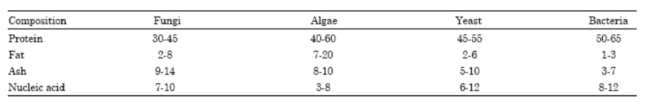
Courtesy: Miller and Litsky (1976)
Like any other microbial culture, production of pure microbial cultures for desired protein products requires a carbon source, nitrogen source, and a source of other nutrients like phosphorus to support optimal growth of the culture. Contamination is prevented by maintaining strict sterile conditions throughout the process. The components of the culture media are either heat sterilized or filtered through microporous membranes. The selected microorganism is then inoculated in pure conditions. Most of the processes are highly aerobic, except algal fermentation; hence a good supply of oxygen is an indispensable requirement. After multiplication of the biomass, it is recovered from the medium and purified further for enhanced usefulness and/or storability.
Large-scale SCP production has multiple advantages over conventional food production practices such as:
- Microorganisms have a high rate of multiplication which means a large quantity of biomass can be produced in a comparatively shorter duration.
- The microorganisms can be easily genetically modified to vary the amino acid composition.
- A broad variety of raw materials, including waste materials, can be used as a substrate. This also helps in decreasing the number of pollutants.
- Production is independent of climatic conditions.
Despite these advantages, SCPs have not been widely accepted for human consumption owing to certain problems as follows:
- High level of nucleic acid in biomass makes it difficult for consumption as it may lead to gastrointestinal problems.
- The biomass may trigger an allergic reaction if the digestive system recognizes it as a foreign product.
- The capital cost of production is high as sophisticated machinery is required.

